



Implementation of Logical Operators in Python
LAB MANUAL

Disclaimer: The content is curated from online/offline resources and used for educational purpose only
Implementation of Logical Operators in Python
Objective:
To understand and demonstrate the use of logical operators in Python through practical examples.
Problem Statement:
Logical operators in Python are used to combine multiple conditions and return a boolean result (True or False). This lab manual demonstrates the implementation and usage of the three logical operators: and, or, and not.
Equipment Required:
- Install VS Code - https://code.visualstudio.com/download
- Download Python Installer File - https://www.python.org/downloads/
Prerequisites:
- Basic Computer Skills - Anyone starting to learn computer programming needs basic computer skills. Python is a cross-platform language, so it makes no difference whether you use a macOS, Windows, or even Linux.

Code:
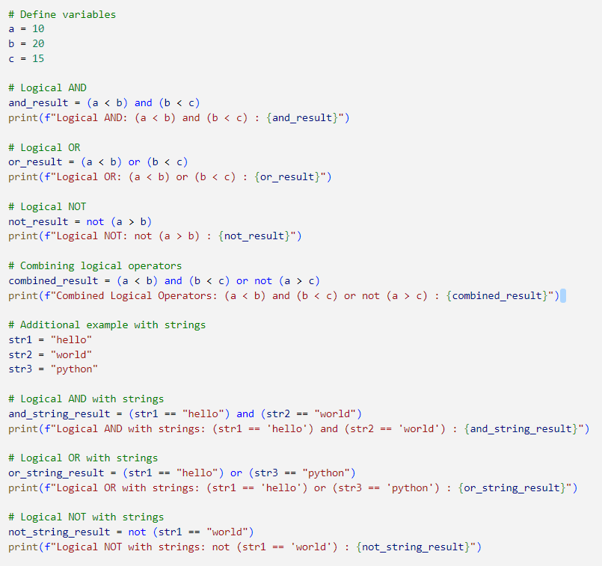

Output:
